Audit form: Hand and wrist orthoses for adults with rheumatological edition – Second edition

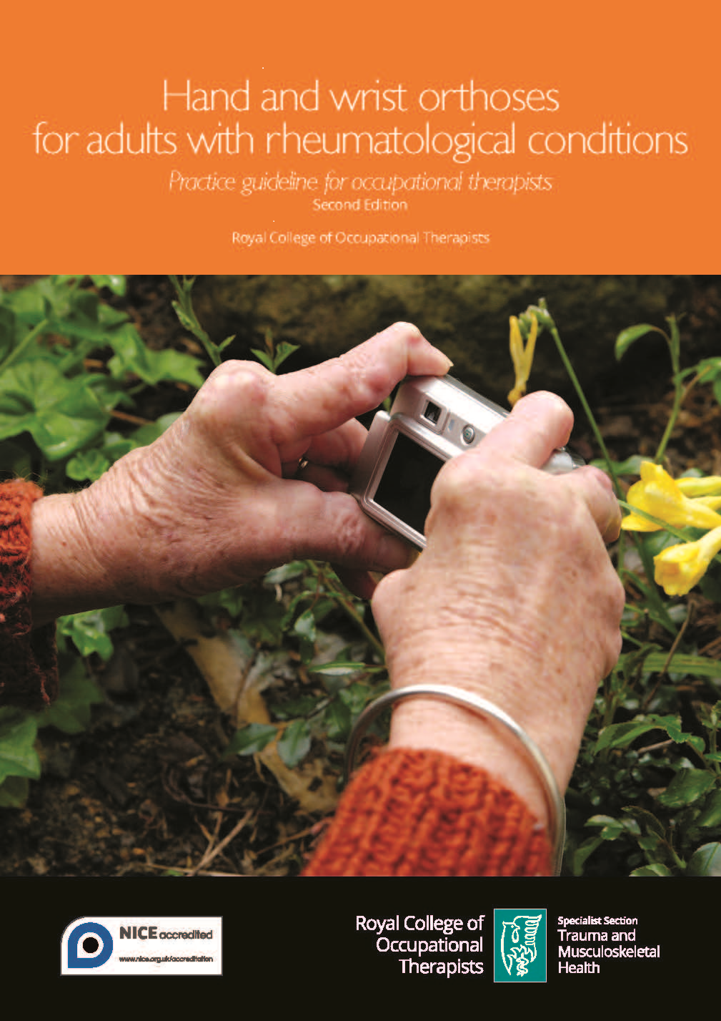This audit tool is to be used in conjunction with the evidence-based practice guideline Hand and wrist orthoses for adults with rheumatological conditions – Second edition (RCOT 2020).

These evidence-based recommendations are not intended to be taken in isolation and must be considered in conjunction with the contextual information provided in the full guideline, together with the details on the strength and quality of the recommendations. The recommendations are intended to be used alongside clinical expertise and, as such, the occupational therapist is ultimately responsible for the interpretation of the evidence-based guideline in the context of their specific circumstances and the people accessing their services.

The full practice guideline, including a 2022 addendum, and implementation resources can be found on the Royal College of Occupational Therapists website.

Reference
Royal College of Occupational Therapists (2020) Hand and wrist orthoses for adults with rheumatological conditions – Second edition. London: RCOT.

Please ensure you save this document to your computer otherwise your changes will be lost.

Date of audit |  | Auditor |  | Role
Location |  |  | Review due date

Recommendations

Rheumatoid arthritis: orthoses for activity and rest |  | What is your current practice? How do you evidence this? | Comments  Actions to be taken by whom and by when

Functional wrist orthoses
A functional wrist orthosis is prescribed for people experiencing wrist pain as a result of rheumatoid arthritis.

Resting/night orthosis
Subjective and objective measures are used to monitor and review the effectiveness of a night or resting orthosis to help reduce symptoms for people with rheumatoid arthritis.

Orthoses for swan neck deformity
When considering an orthosis for swan neck deformity, the potential positive effect on dexterity is balanced by possible adverse effects, such as pressure and paraesthesia.

Osteoarthritis: base of thumb orthoses |  | What is your current practice? How do you evidence this? | Comments  Actions to be taken by whom and by when

Orthoses to reduce pain and/or improve function
An orthosis is prescribed for people experiencing pain and/or functional difficulties with activities of daily living as a result of thumb base osteoarthritis.

Orthoses to improve grip and pinch strength
Improvement of grip/pinch strength for people with thumb base osteoarthritis as a result of wearing an orthosis is documented.

Optimising outcomes for people accessing services |  | What is your current practice? How do you evidence this? | Comments  Actions to be taken by whom and by when

Measuring outcomes
Validated, standardised assessment and outcome measures are used pre- and post-provision of an orthosis to monitor progress and evaluate effectiveness. Measures may include assessing functional outcomes, understanding individual satisfaction and utilising Patient Reported Experience Measures (PREMs).

Orthoses design and wearing regimen
The orthosis selected and wearing regimen prescribed maximises occupational performance and individual choice.

Experiences of people who access services
In order to optimise adherence to wearing a prescribed orthosis, the following is discussed with the person:
- the potential benefits and limitations;
- information on the practicalities of use and comfort;
- the opportunity to try on orthoses prior to issue;
- a routine follow-up review of the intervention.

Compression gloves |  | What is your current practice? How do you evidence this? | Comments  Actions to be taken by whom and by when

Hand pain, function or stiffness

Compression gloves are not recommended for hand pain, function or stiffness.

Potential perceived benefits
Consideration is given to the perceived benefits that a loose-fitting, three-quarter length glove may provide for warmth, comfort and support.

