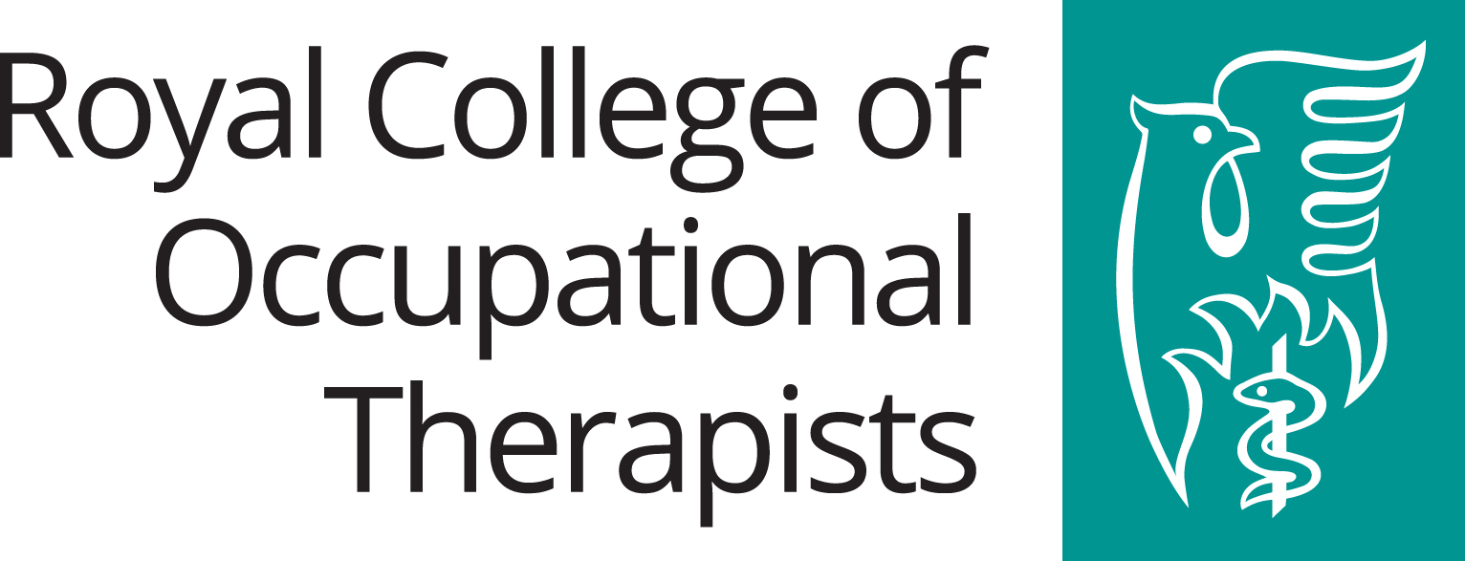
Consultation Proposals for amendment of Technical Booklet Guidance to Part R (Access to and use of buildings) – Changing Places Toilet Provision July 2021 (Northern Ireland)
Q1: Do you support the proposal to introduce criteria for Changing Places Toilets (CPT) facilities provision (in addition to the current accessible sanitary provisions), in certain buildings through building regulations statutory guidance?

The Royal College of Occupational Therapists supports the proposal to introduce criteria for CPT facilities provision.

Occupational therapists consider the relationship between what a person does every day (occupations), how illness or disability impacts upon the person and how a person’s environment supports or hinders their activity (PEO Model). Using this approach, occupational therapists help people to continue or re-engage with participating fully in daily life, including work, social activities and maintaining roles and responsibilities. The College therefore supports this initiative.
Q2: Do you agree with the defined in scope/relevant types of large buildings commonly used by the public, where a CPT facility should be provided for a new building or where a building is formed by a material change of use?

The Royal College of Occupational Therapists welcomes the proposed increased provision of CPTs.

Q3: Do you agree with the set criteria (the building function, its people capacity or gross floor area) for the defined in scope/relevant buildings?
Yes.
Q4: The Department acknowledges that there may be complexities associated with CPT provision in existing buildings undertaking extension or alteration works, but would welcome further views and supporting evidence. Do you agree with the Department on the need for further supporting evidence and can you provide such, regarding CPT retro-fit installation to existing buildings undertaking extension or alteration works?

It is important to engage professionals with the appropriate skills in assessment to ensure the environment meets people’s needs. Many occupational therapists are skilled in this type of assessment and can advise on accessible and adaptable environments to meet the needs of people with disabilities.

Q5: Do you agree with the analysis/principal assumptions, costs and impacts set out in the Part R consultation stage RIA?
N/A
Q6: Have you any additional comments on the proposals you wish to provide?
It is positive for residents of Northern Ireland that the provision of CPTs is being reviewed. There are often occasions where appropriate toilet provision is not available for people requiring it when out in the community. A lack of basic toilet requirements contributes significantly to lack of equity of opportunity.
Increased provision of Changing Places toilets would help to promote social inclusion for people with disabilities and their carers. This would assist in reducing the stigma and discrimination people may face. The increased provision would recognise the need for extra facilities that would assist people to engage in meaningful occupations (activities that are important to them). It would also encourage people to access buildings in their communities that they may previously have avoided. Increased provision would help reduce the current limitations people experience regarding where they choose to travel to.
Additional information: please see section 4 of https://www.pmldlink.org.uk/wp-content/uploads/2017/11/Standards-PMLD-h-web.pdf

