Leadership Principles for Health and Social Care in Wales:

FOREWORD

‘A Healthier Wales: Our Plan for Health and Social Care’ outlines the urgency for “dynamic leadership that instigates change, empowers others and creates the conditions for continuous innovation and improvement that drives up the quality and value of services”.

The emphasis on a “motivated and sustainable” workforce within the draft health and social care workforce strategy reinforces the importance of effective and compassionate leadership to the wellbeing of all staff, outlining our ambition that “by 2030 leaders in the health and social care system will display collective and compassionate leadership”.

Our intention to adopt collective and compassionate leadership across health and social care in Wales has been informed by significant evidence-based research including the work of credible experts Professor Michael West and The Kings Fund. Feedback on the Workforce Strategy consultation process also highlighted the need for compassionate leadership across the system, and its critical link to culture and wellbeing. This approach is consistent with the other UK countries who are also working towards this.

The key features of collective leadership are as follows:
- It’s about team capacity to lead not just individual capacity
- This means nurturing everyone’s leadership capacity, not just in a hierarchical sense
- There is a clear focus on stimulating and supporting quality improvement and innovation
- This needs trust and a new psychological contract, sharing power and decision making
- Compassion is central to this approach – empathy, listening, acting and valuing our people

We developed a set of principles earlier in the year and tested these with partners. However, the impact of COVID-19 meant that not everyone was able to provide feedback and so we suspended the consultation. In the interim we have taken the opportunity to reflect on the feedback that we had received prior to COVID-19 as well as the learning during the initial phase of the pandemic. As a result, we have refined the principles and are now looking to test these with partners and stakeholders. The principles are:

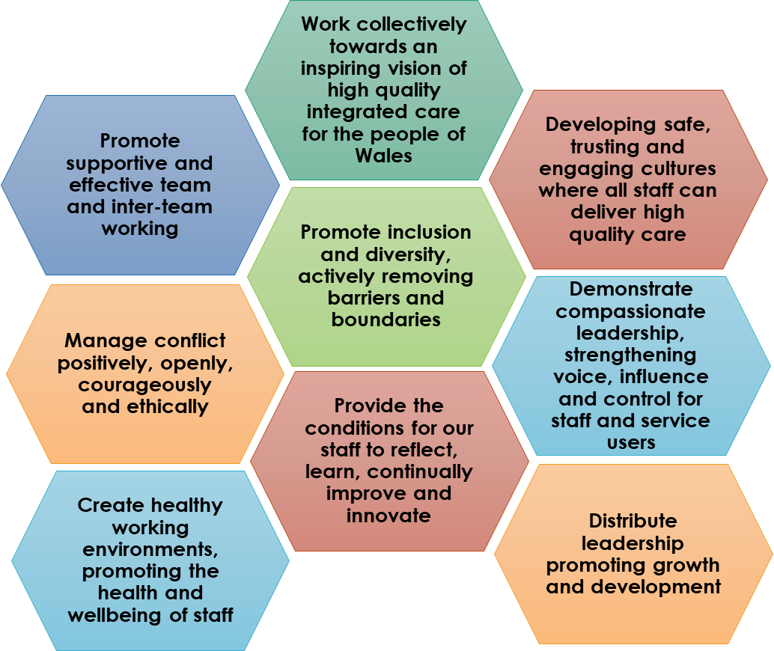
The context and evidence for this is set out in the document. We want these principles to be visible in our leadership across the whole of the health and care system.
When finalised we intend to bring these principles to life through a series of interviews with leaders at all levels who will describe the benefits experienced by our staff and the people who use our services when a collective and compassionate approach to leadership is embedded.
To mobilise these principles, Frameworks for Action will be developed, based on the priorities and pace for the health and social care sectors. Resources including the frameworks for action will be available digitally. HEIW provides links for examples of leadership resources hosted on our Gwella Leadership Portal https://nhswalesleadershipportal.heiw.wales/. Social Care Wales provides leadership resources on their website www.socialcare.wales
We believe these compassionate leadership principles will help steer us towards creating cultures where employees feel valued, safe and empowered to continuously improve the services they provide to the people of Wales. We would welcome your views on these draft principles as part of our engagement process, specifically in relation to the following questions:
- Do the principles and compass capture the right things?
- Is there anything missing that you'd have hoped to see there?
- Would you be content to endorse these principles on behalf of your organisation so that we build the mandate for action?

The consultation is open until midnight on 27th September 2020.

We appreciate your contributions and invite you to forward your comments by emailing: HEIW.Leadership.Programme@Wales.NHS.UK

Alex Howells Sue Evans
Chief Executive Chief Executive
Health Education & Improvement Wales Social Care Wales

